CS3102 Lab 4

Task 1:
Task 2:
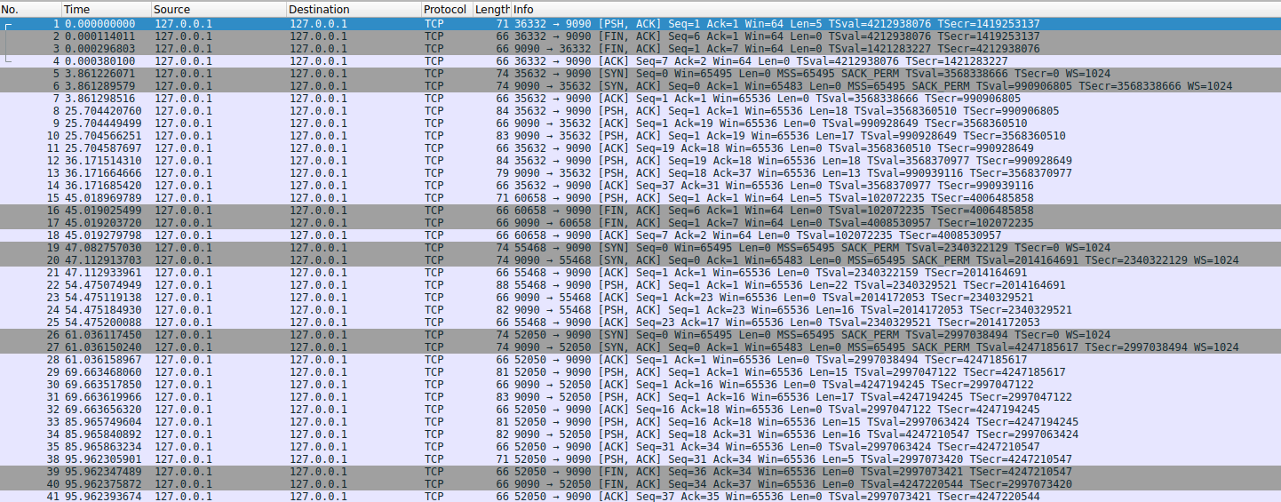
The four-tuple set distinguishes them all from each other:
- Source IP
- Source Port
- Destination IP
- Destination Port
Task 3:
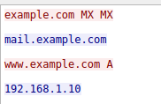
Task 4:
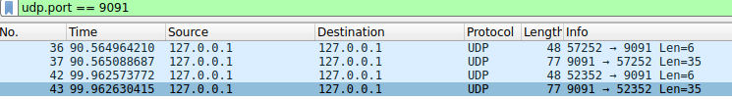
Task 5:
TCP shows connection-management packets (handshake, and FIN/ACK teardown on disconnect), UDP shows only the request and reply datagrams, no setup or teardown packets at all.
The TCP stream can carry multiple queries back-to-back on one connection (you can see several request/response exchanges inside one stream), while each UDP exchange is a single, independent request/response pair with no persistent connection state.

